1. **Add using lambda**

**package** io.lasya;

**public** **class** Lambda {

**public** **static** **void** main(String[] args) {

Myadd addFunction = (**int** a, **int** b) -> a + b ;

System.***out***.println(addFunction.add(10, 20));

}

**interface** Myadd{

**int** add(**int** x, **int** y);

}

}

Output

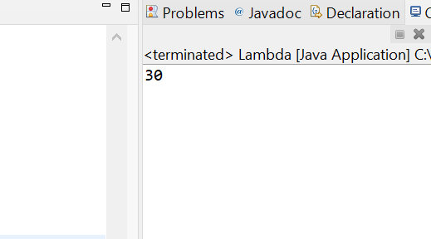

Sub using lambda

**package** io.lasya;

**public** **class** Lambda {

**public** **static** **void** main(String[] args) {

Myadd subFunction = (**int** a, **int** b) -> a - b ;

System.***out***.println(subFunction.sub(40, 20));

}

**interface** Myadd{

**int** add(**int** x, **int** y);

}

}

Output: 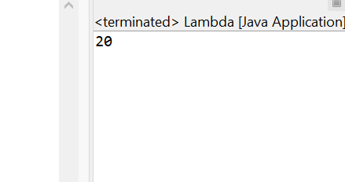

Mul using lambda

**package** io.lasya;

**public** **class** Lambda {

**public** **static** **void** main(String[] args) {

Myadd mulFunction = (**int** a, **int** b) -> a * b ;

System.***out***.println(mulFunction.mul(40, 20));

}

**interface** Myadd{

**int** add(**int** x, **int** y);

}

}

Output

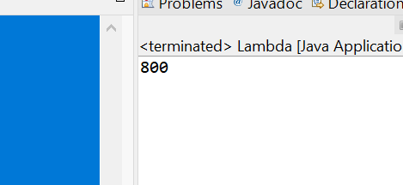

Div using lambda

**package** io.lasya;

**public** **class** Lambda {

**public** **static** **void** main(String[] args) {

Myadd divFunction = (**int** a, **int** b) -> a / b ;

System.***out***.println(divFunction.div(40, 40));

}

**interface** Myadd{

**int** add(**int** x, **int** y);

}

}

Output

